RANKING ROUND UP / Top 10 Institutions

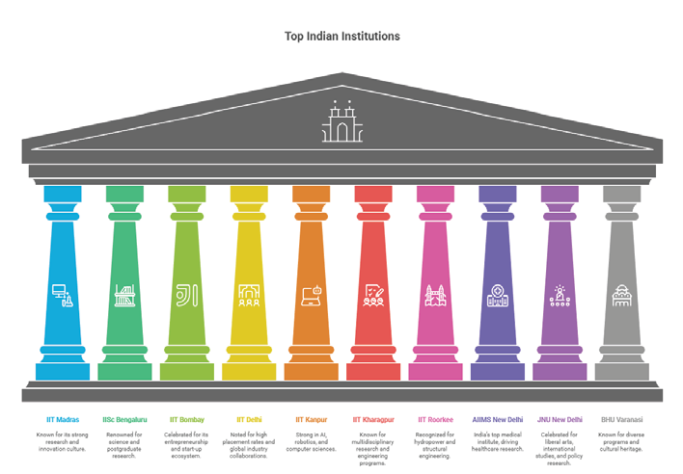
Top Ten Institutions
IISc Bengaluru IIT Bombay
Renowned Celebrate for its
for science entrepreneurship
and postgrdute and start-up research
IIT Delhi
Noted
high placement rates and global
industrial collaboration
IIT Roorkee AIIMS New Delhi JNU New Delhi BHU Varanasi
Recognised for India’s top Celebrate for liberal Known for program
hydro power and
medical Institute art and international and cultural heritage
tructural engineering driving
study and
health research policy research
IIT Kharagpur
Known for’ multidisciplinary research and s engineering programmes
IIT Kanpur
Strong in
AI robotics its and
computer science
ecosystem
IIT Madras Known for its storng research and Innovation
cultural

Trends and changes for 2025
The rankings recorded in 2025 show that the IITs and IISc continue to be powerhouses, comprising seven of the ten highest-scoring institutions. Their positions appear strongly justified and are on the backs of a decades-long commitment from the government and utility of built research infrastructure into educational leadership. The ranking metrics highlight the growing relevance of medical sciences (in the form of AIIMS), liberal arts (with JNU), and multidisciplinary education (BHU), with all three institutions in the top 10.Interestingly, private institutions, such as Manipal Academy of Higher Education (MAHE) and some of the others, have seen a huge increase
relative to their own institutional peers that reflect possibilities for private investments in advancing the landscape of higher education.
Future Pathways
While NIRF is well-respected, there are detractors. The pervasive emphasis on research output and perception tends to privilege the old-school, established university that also has a long, storied history. Upstart universities that might be exemplary in terms of student support, student and faculty inclusivity, and the quality of teaching, cannot move up the ranks as quickly. Moreover, as issues such as mental health, safety in hostels and apartments, and general well-being do not have any representative measures in the current rankings.
have any representative measures in the current rankings. have any representative measures in the current rankings. These would represent a more concerted effort toward aligning India’s ranking system closer to global ranking systems, such as the QS World University Rankings or Times Higher Education (THE).
The NIRW 2025 Top 10 list reflects the pride of existing academic behemoths in India, yet remains a pathway for the whole system's next destination. For students: rankings are the barometer of futures, but still one of many tools to inform their future direction. For policymakers: an opportunity to expand the reach of excellence beyond IITs and AIIMS; so that, India's many millions of students are assured the opportunity for quality; on their terms; and at their site of study.

55 / clearcutmedia.co.in

